**Cluster Configuration**

Use Microsoft documentation

[New-Cluster (FailoverClusters) | Microsoft Learn](https://learn.microsoft.com/en-us/powershell/module/failoverclusters/new-cluster?view=windowsserver2022-ps)

Step 1: Go the primary node and open powershell

1. Using GUI: open “server manager” – click “failover cluster manager”

1. Follow the steps and validate the cluster

Use domain\accountname (since we have added this to the Active directory)

e.g Prod\sqladmin

1. Add the VMs to be validated

1. Finally run all tests.

Step 2: create cluster

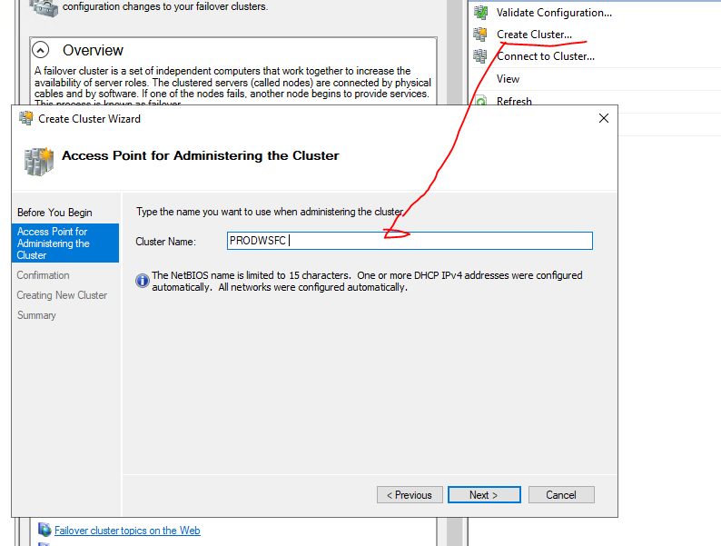

Uncheck the box for AG

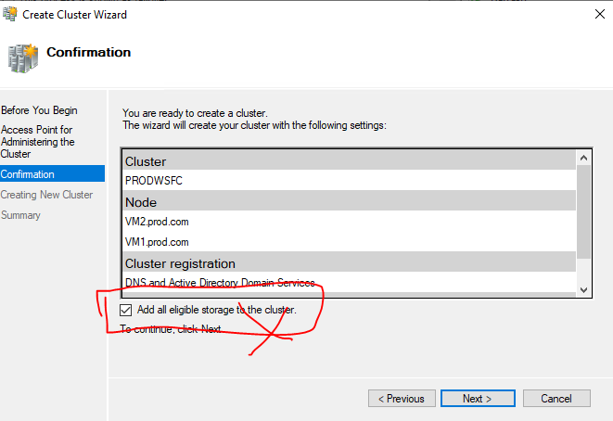

The Cluster is created. Check the Nodes. The default uses distributed server name (DSN). DSN doesn’t have its own IP address, it is registed with the IP addresses of the nodes in the cluster in the DNS server.

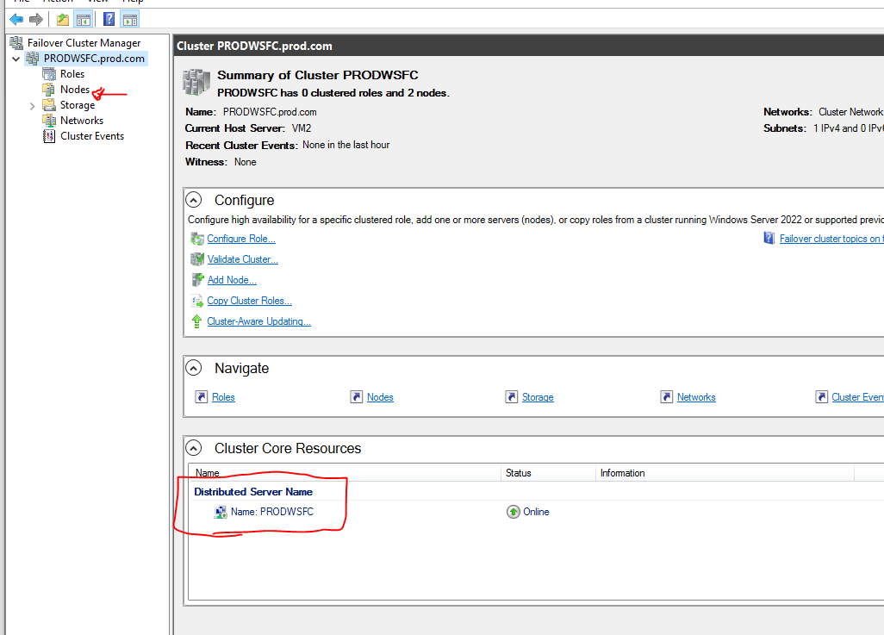

**Optional: Using PowerShell to create Cluster**

New-Cluster -Name PRODWSFC -Node VM1,VM2 -NoStorage

--On VMs with 2019 and 2022 windows, a cluster is created with Distributed server name, which avoids the need for load balancer for the VMs. But a load balancer will be needed if we create a listener with VNN.

**Reference**

[Configure a single-subnet availability group (PowerShell & Az CLI) - SQL Server on Azure VMs | Microsoft Learn](https://learn.microsoft.com/en-us/azure/azure-sql/virtual-machines/windows/availability-group-az-commandline-configure?view=azuresql&tabs=azure-cli)